Saco Salmon Restoration Alliance & Hatchery News and updates: July 14, 2020

January 2020
49 wild Atlantic salmon broodstock weighing between 5 & 6 pounds were released into the Saco River at an undisclosed location.

February 2020
February 1, 2020, two teams were sent out to area streams with Redd-O-Matics and planted 14,400 eyed-up wild Atlantic salmon eggs. A team planted more eggs February 8th. This was the last egg planting event for 2020.

An aquarium, similar to Fish Friends program equipment, was set up in the basement of the hatchery to hold all the remaining salmon eggs. This aquarium saved $300 in February and $600 a month in electricity costs in March and April.

March 2020
We continue to maintain the broodstock at the hatchery.

April 2020
No tours or open houses are scheduled because of the COVID-19 pandemic.

We continue to hold our broodstock, e-fished Parr and about 1500 fry in the aquarium. Because of COVID-19 school shutdowns and there was limited or no access to the aquariums in the schools, the Fish Friends program participants elected to return their fry to the hatchery. The Fish Friends fry have been added to the fry in the hatchery to be raised all together. Stocking fry have not been an option for this year. We are currently planning on raising the fry for future broodstock.

May 2020
The salmon fry were transferred from the aquarium to a trough in the nursery area of the hatchery where they can be easily cared for. They are growing rapidly!

June 2020
The new larger hatchery generator and larger propane tank were installed on June 10th and 11th and are in working order.

On June 24, 2020, with the help of 14 volunteers, 56 wild Atlantic salmon broodstock were netted and moved from the hatchery basement tanks to the UNE Marine Science Center (MSC) tanks that were on a trailer attached to a UNE MSC pickup truck. Aurora Burgess made sure that the fish were moved safely to the UNE MSC. Only UNE MSC personnel are allowed into the UNE MSC facility at this time. Aurora has reported that the fish were recovering nicely from the short trip and adjusting to their new environment and beginning to feed.

July 2020
Aurora Burgess reported that there are 55 healthy broodstock at the UNE MSC.

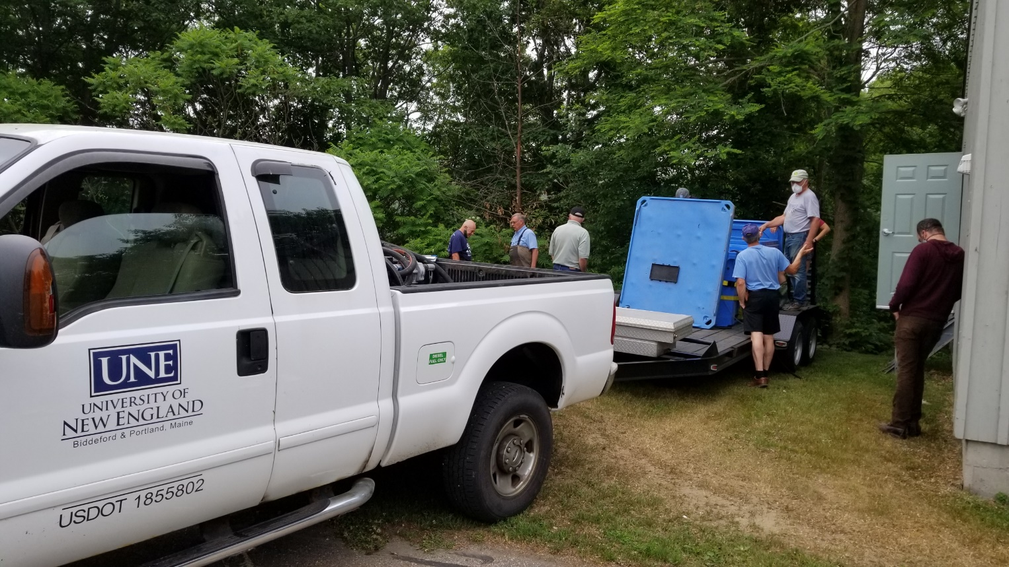
Preparing the UNE MSC tanks for the broodstock on moving day. Filling tanks with hatchery water.

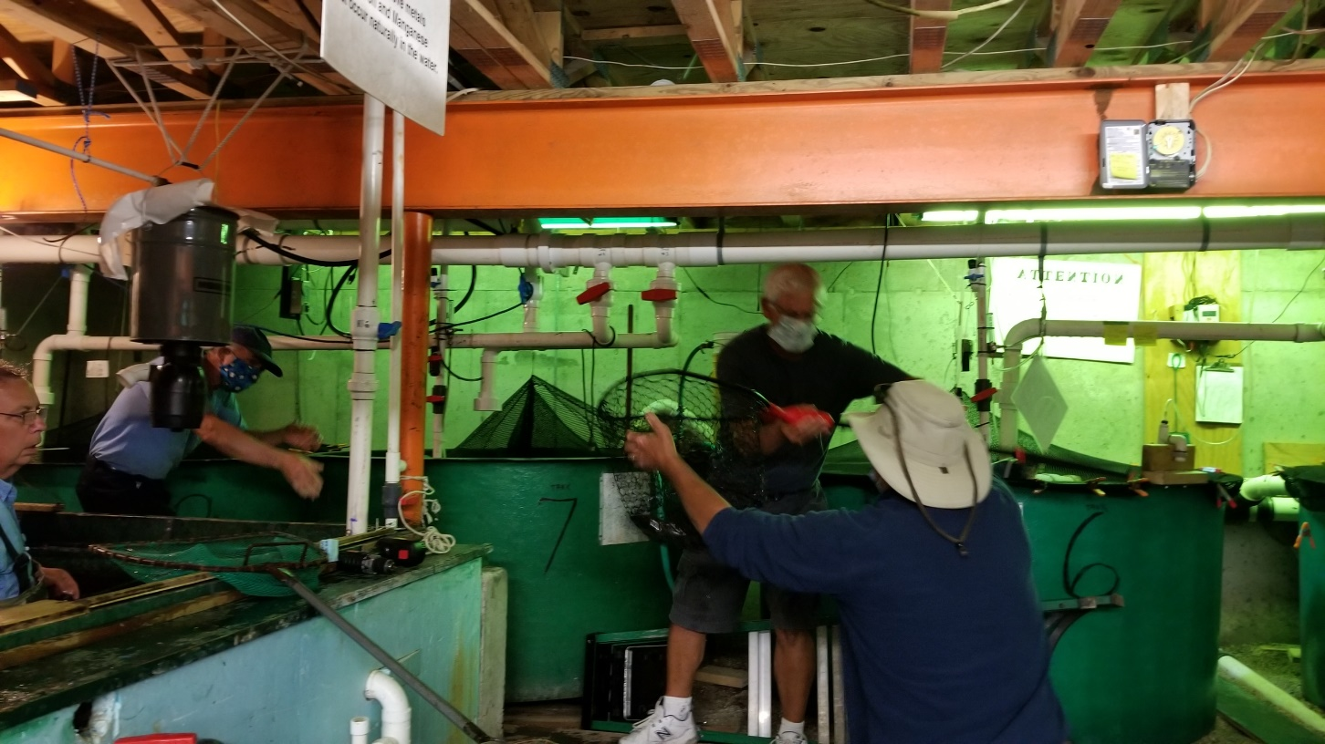
Volunteers netting the fish in the hatchery basement.
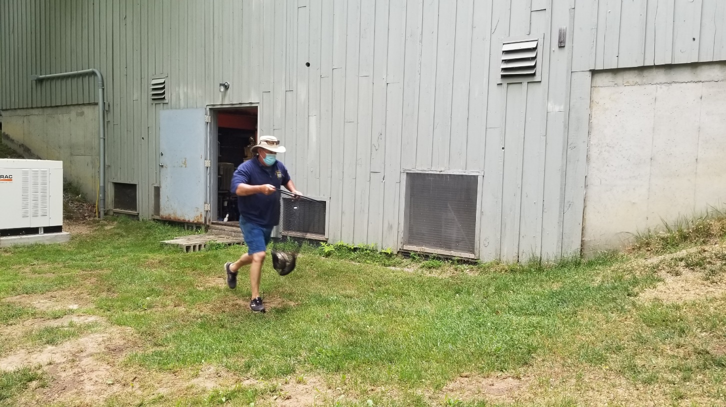
Steve Berry charging up the hill from the basement of the hatchery with broodstock salmon.
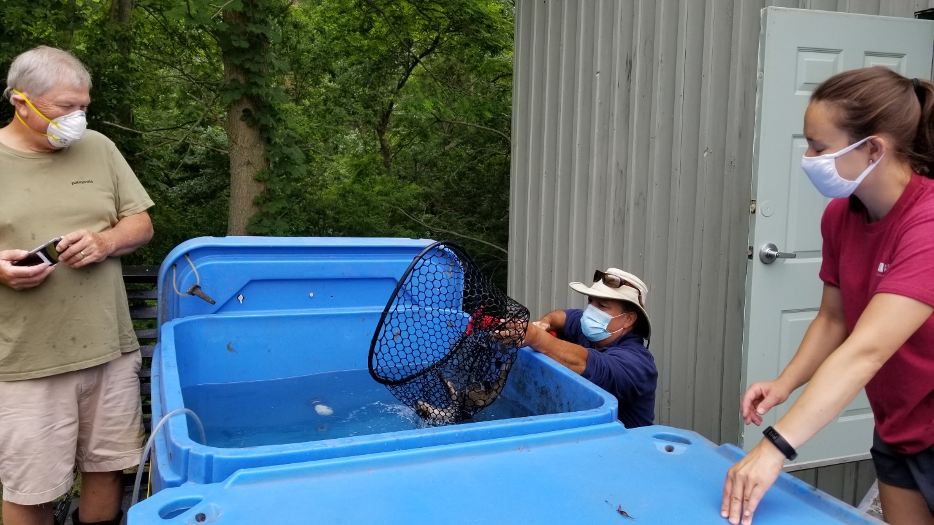
David Adams & Aurora Burgess watching Steve Berry dropping a broodstock into the tank on the trailer of the UNE MSC.

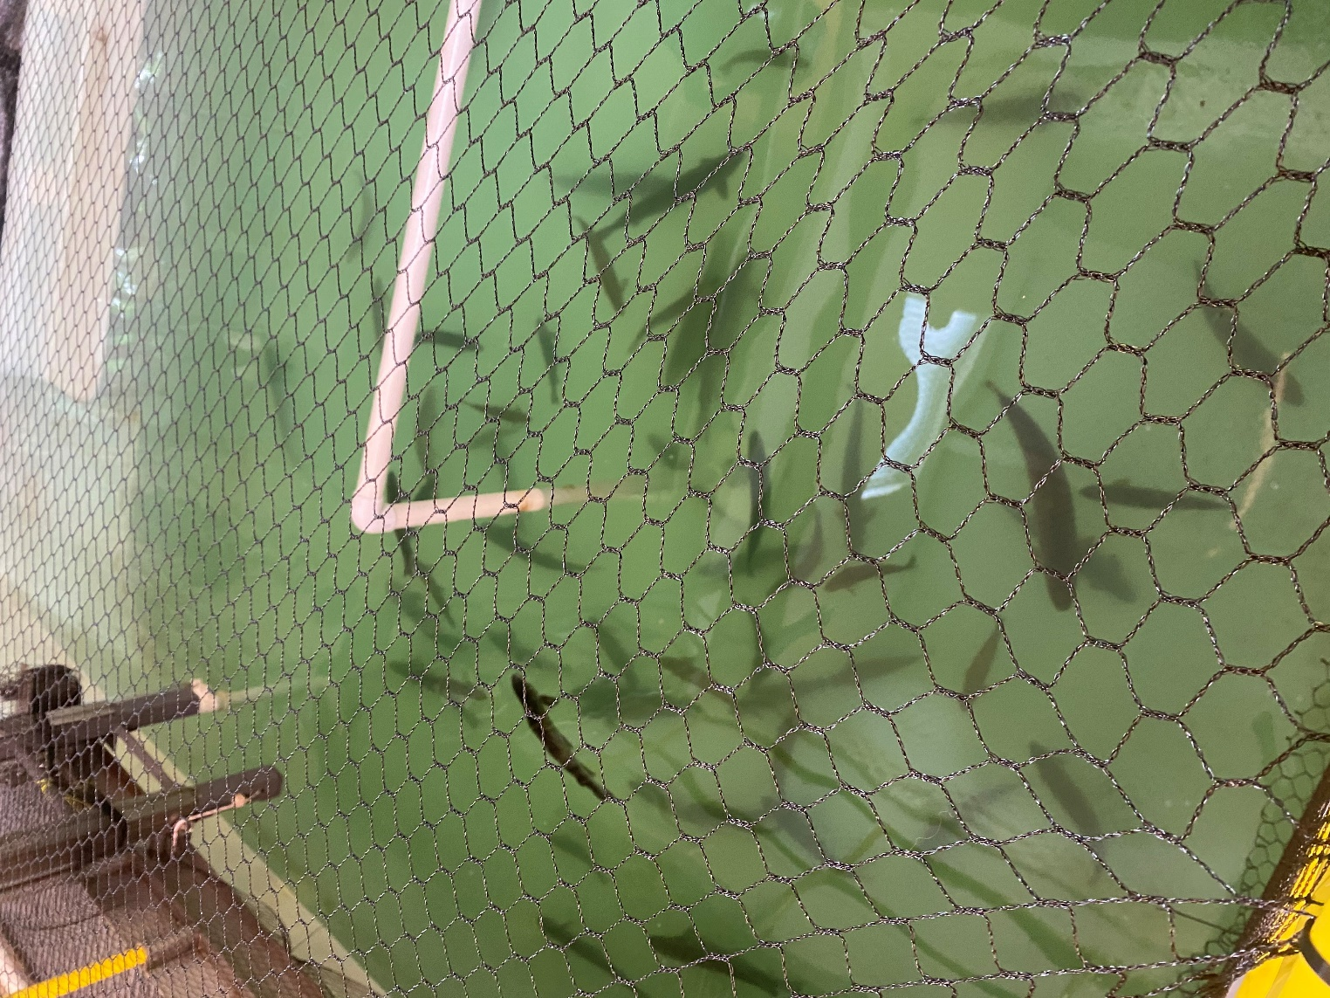
56 wild Atlantic salmon broodstock in their new home at the UNE MSC.

Garry Kasten, Treasurer
SSRA&H
PO Box 115
Saco, ME 04072
www.sacosalmon.com
gkasten42@gmail.com
Saco Salmon Restoration Alliance & Hatchery is a non-profit 501(c) (3) corporation. EIN: 223011032 Your donations are tax deductible as allowed by law.

